I chose to make a website about the UEFA champions league and used basic/intermediate html and css coding.

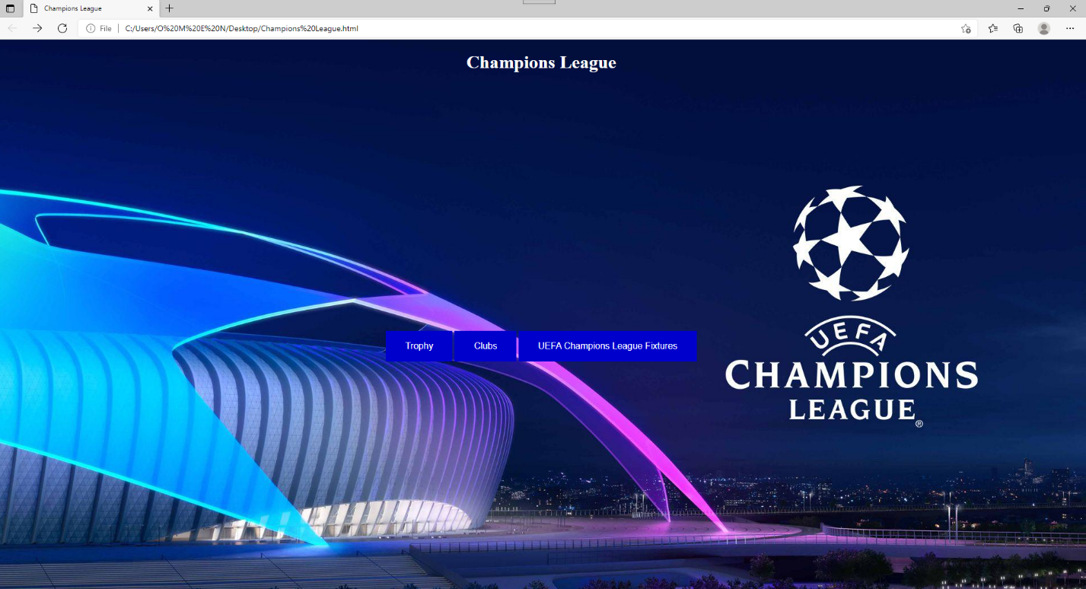

For the homepage the image used was for one of the pictures taken during the champions league event, and on the top of the page the name is also included.

Three buttons were inserted to access a hyperlink which sends the user to either trophy, clubs and the UEFA champions league fixtures.

Hover’s were also inserted on the buttons.

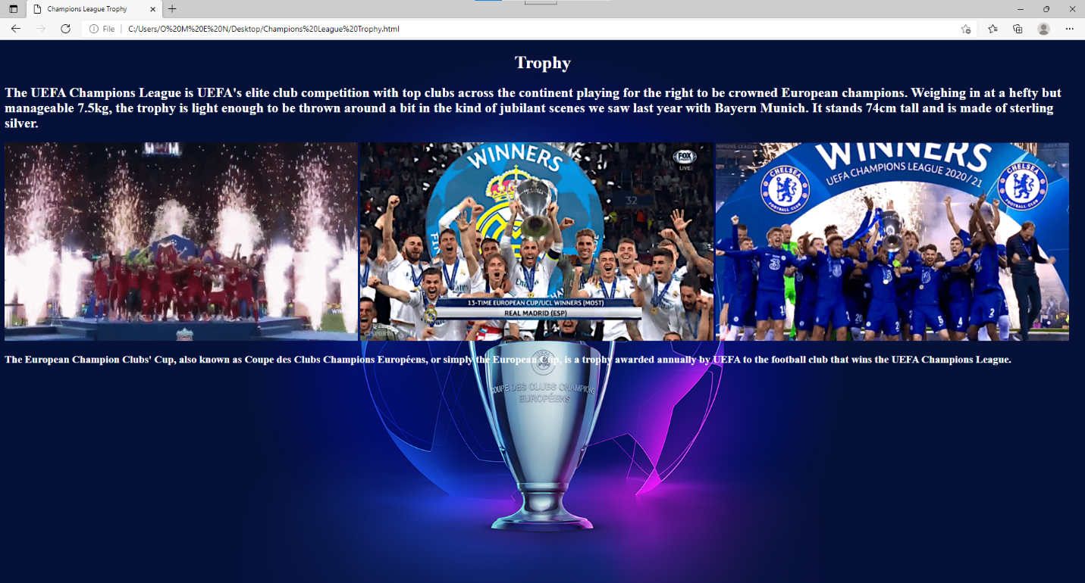

Here we see the trophy page which talks about the trophy and all.

3 gif’s were added in order to make the page look more alive.

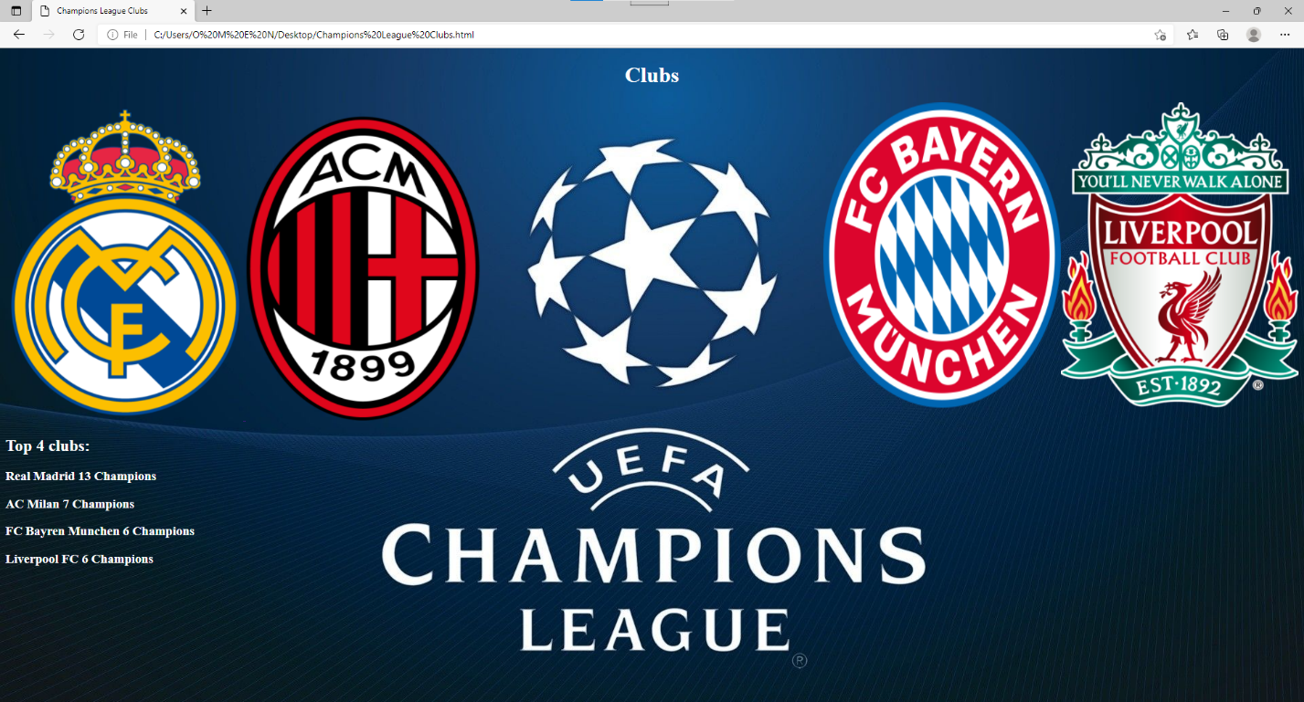

This is the club page, it shows us the clubs that won the most champions league out of all the other teams, pictures of the clubs were also inserted and a text on the bottom left with the clubs names and the number of champions leagues won

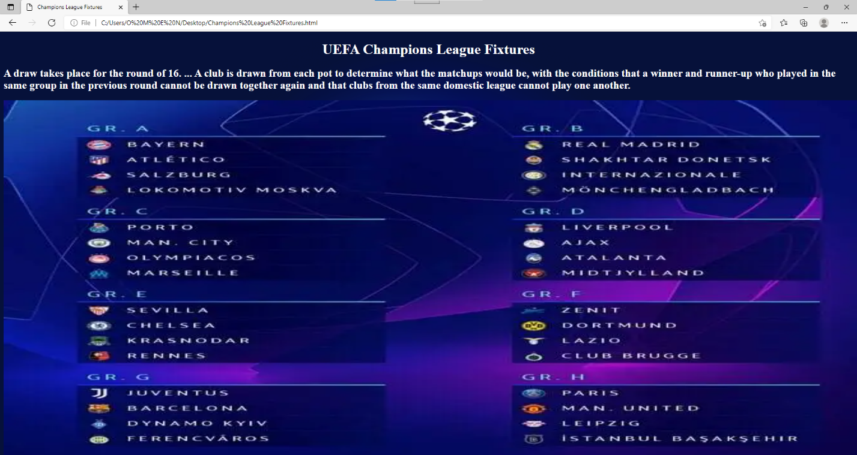

This is the fixtures page, has both information about the fixtures and how the round of 16 is drawn and how the group stages are set in a photo.